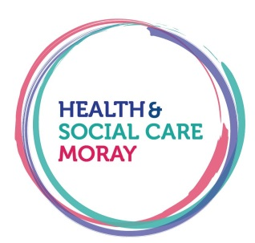
TEAM REFERRAL TO
COMMUNITY ADULT LEARNING DISABILITY TEAM

Patient Details |  | Carer Details
Name:  DOB:  CHI:  Care First No: |  | Name:  Designation:
Address:  Postcode: |  | Address:  Postcode:
Tel. No:  Mobile No: |  | Tel. No:  Mobile No:
Next of Kin – Name, Relationship and Address:

Living Alone: | Or with Family: |  | Or in Supported Accommodation:
Does this person have a guardian? Y/N
If YES, Name, Address and Phone Number –

Consent to Referral:
- Verbal Client
- Signature of client/guardian Parent/guardian

In the absence of capacity to consent to this referral is there a valid section 47 certificate in place? Y/N
Is there any identified risk? Yes / No

If Yes, please identify risk:
Services available are: (please tick service required).
Team Referral  Clinical Psychology Community Nursing  Dietetics |  | Occupational Therapy  Physiotherapy  Psychiatry  Speech & Language Therapy  Social Work

Reason for referral / Presenting Problem
(Please give as much information as you can e.g., has a diagnosis of an LD been made, what you hope the LD service will provide to the individual)

GP Name and Address:
Signature: Date:

Print Name in Block Capitals:

Designation: Contact Phone Number:

On completion please send this referral to:

Community Learning Disability Team
The Moray Council, Council Offices
10 High Street
Elgin
Moray
IV30 1BX
Tel: 01343 563211

Email: GRAM.MorayCommunityLearningDisabilityTeam@nhs.scot or learning.disability@moray.gov.uk

ADMIN USE ONLY
Referral received by:

Date received:

Open to:

Accepted by:

Rejected:

More Information required:

Date response letter sent to referrer:

